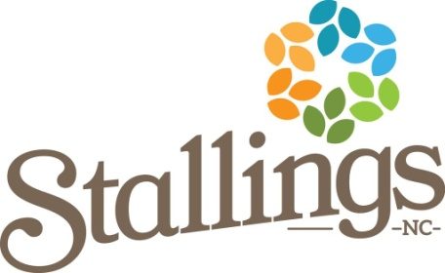

Notice
of the
Town of Stallings
Parks & Recreation Committee

Please note the following meeting of the Stallings Parks &
Recreation Committee has been CANCELLED:
December 13th, 2022
6:00 PM
Government Center
321 Stallings Road Stallings, NC 28104

This is the 13th day of December 2022.

s/ Eunice McSwain
Eunice McSwain, Parks and Recreation Director

